KasiGuru: A Gamified Mobile Learning Application for the Preservation and Learning of the Kasiguranin Language

By

Bihasa, Erickson
Cordial, Anthony T.
Miras, Adrian Rhoman V.
Ruidera, Owen

A Capstone Project Submitted to the School of Information Technology of the Aurora State College of Technology in Partial Fulfillment of the Requirements for the Degree of
Bachelor of Science in Information Technology

May 2026

I. INTRODUCTION
Language is a cornerstone of cultural identity, yet regional speech varieties are rapidly declining due to globalization. In Casiguran, Aurora, coastal lowlanders speak Kasiguranin, a unique, non-Negrito Austronesian language that shares an 88% cognacy rate with the neighboring indigenous Casiguran Dumagat (Agta).
While the Expanded Graded Intergenerational Disruption Scale (EGIDS) classifies Kasiguranin as Status 6a (Vigorous), it faces long-term threats from urban migration and the dominance of Tagalog and English. A lack of documentation leads many to mistake it for a mere dialect rather than a distinct language. Furthermore, traditional oral transmission lacks the digital engagement needed by younger generations.
To address this, KasiGuru: A Gamified Mobile Learning Application for the Preservation and Learning of the Kasiguranin Language integrates digital storytelling, vocabulary matrices, native pronunciation guides, and educational mini-games into an interactive Android platform. This project aims to make language learning engaging, correct regional misconceptions, and secure the digital preservation of Kasiguranin.

BACKGROUND OF THE STUDY
The loss of regional languages threatens cultural diversity and traditional knowledge. Historically, the rugged geography of the Sierra Madre insulated Kasiguranin, preserving its predicate-initial syntax and distinct six-vowel system. However, modern infrastructure and socioeconomic shifts are accelerating integration into Tagalog-centric domains.
Kasiguranin features a complex morphological system where verbs are inflected for aspect rather than chronological tense. Younger speakers increasingly replace these rules with Tagalog code-switching. Mobile learning (m-learning) combined with gamification mechanics (rewards, quizzes, progression tracking) offers a proven framework to boost motivation. KasiGuru translates Kasiguranin’s grammar sketch into an accessible digital repository to foster language preservation.

CONCEPTUAL FRAMEWORK
This study adopts the Input–Process–Output (IPO) model as its conceptual framework, extended with a feedback path, because the study is a development study that transforms identified resources and requirements into a software artifact and an evaluation of that artifact.
Input comprises the raw material and the constraints: Supnet's (2016) grammatical sketch of Kasiguranin; vocabulary and narratives elicited from community speakers and culture bearers; the needs of student and beginner learners and of educators in Casiguran; the ISO/IEC 25010 quality characteristics; and the target Android platform and connectivity conditions of the deployment site.
Process comprises the Phased Development Approach—requirements, analysis, design, coding/implementation, testing, deployment, and maintenance—within which five design mechanisms operate on the input: digitization and semantic categorization of the lexicon; scheduling of review by a spaced-repetition algorithm; application of gamification mechanics for persistence; an offline-first data architecture with opportunistic synchronization; and development of the accompanying administrative web portal for corpus management, submission moderation, and release publishing. The process concludes with evaluation against ISO/IEC 25010 and an acceptability survey administered to the target users.
Output comprises the developed KasiGuru mobile application, distributed as a directly installed Android package; the administrative web portal used to manage the corpus, moderate community submissions, and publish releases; the digitized Kasiguranin lexical corpus and narrative collection as a preservation artifact in its own right; the resulting software quality evaluation; and the measured level of user acceptability.
The feedback path distinguishes this framework from a linear development model. Evaluation results and usability findings re-enter the process as revised requirements, and the application's moderated contribution pipeline returns new linguistic data to the input as community members submit Kasiguranin words that, after expert review, enter the corpus. The corpus is therefore not a fixed input consumed once but a living resource the community extends.
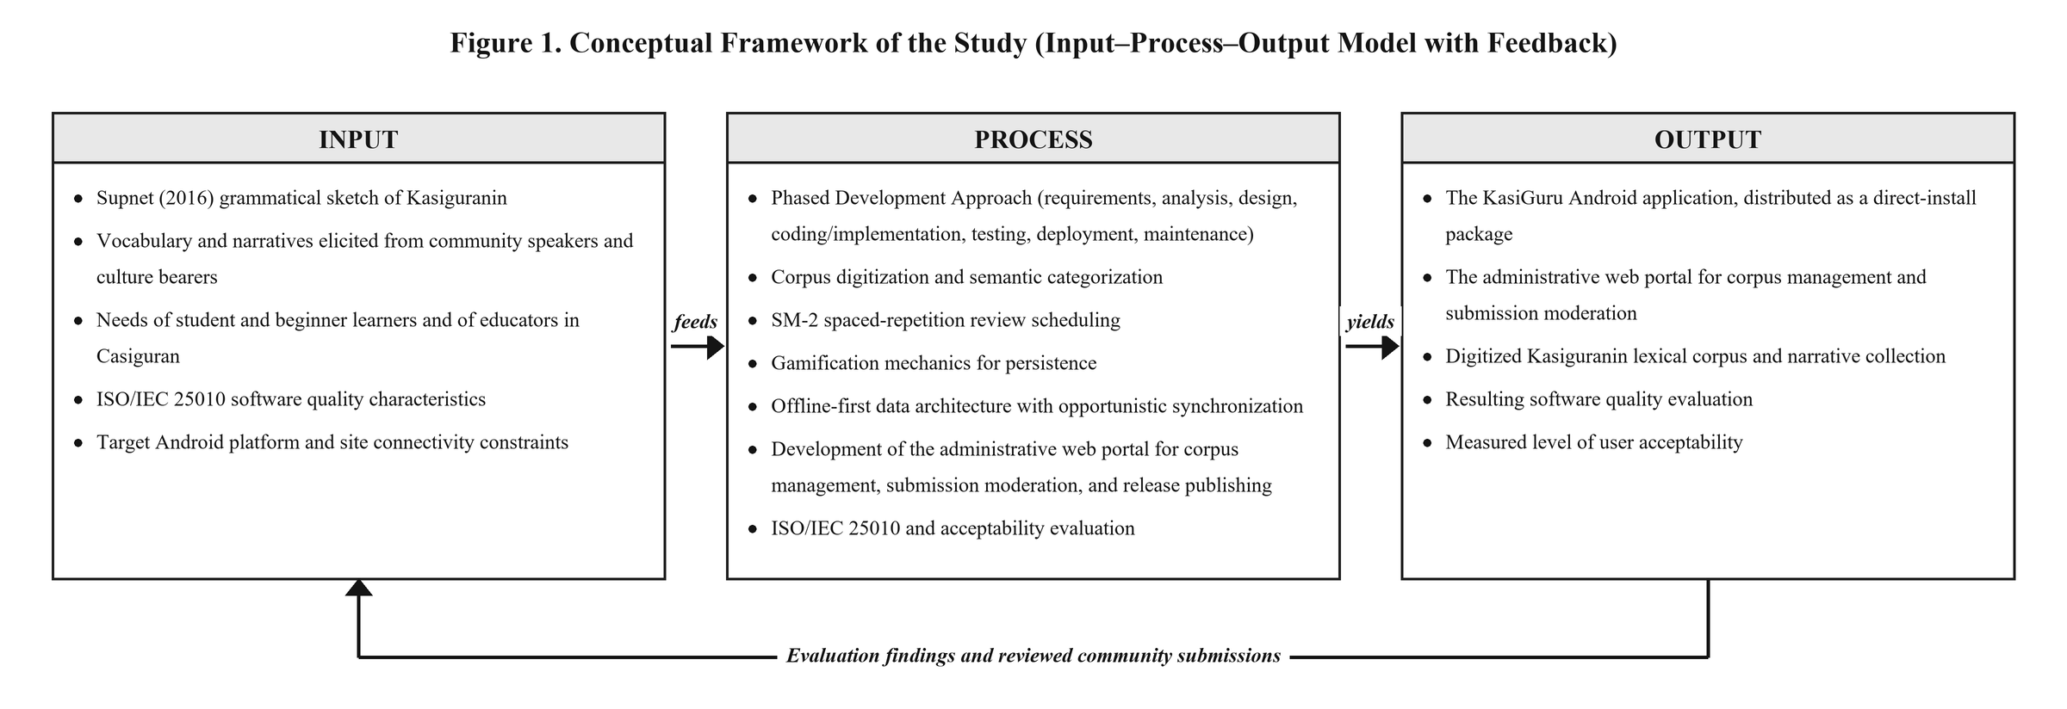
Figure 1. Conceptual framework of the study.

STATEMENT OF THE PROBLEM
This study aims to develop and evaluate KasiGuru, a gamified mobile learning application for the preservation and learning of the Kasiguranin language.
Specifically, it seeks to answer the following questions:
- How may the application be developed using the Phased Development Approach in terms of:
1.1 Requirements,
1.2 Analysis,
1.3 Design,
1.4 Coding/Implementation,
1.5 Testing,
1.6 Deployment, and
1.7 Maintenance?
- How may the application be evaluated based on the ISO/IEC 25010 Software Quality Standards in terms of:
2.1 Functional Suitability,
2.2 Performance Efficiency,
2.3 Usability,
2.4 Reliability,
2.5 Security, and
2.6 Maintainability?
- What is the level of acceptability and user satisfaction of the application among students and beginner learners?

OBJECTIVES OF THE STUDY

General Objective
To develop and evaluate KasiGuru, a gamified mobile learning application for the digital preservation, documentation, and learning of the Kasiguranin language.

Specific Objectives
- Develop an Android learning app featuring interactive storytelling, aspect-oriented vocabulary lessons, and native pronunciation guides.
- Integrate local cultural content, stories, and traditions into the application database.
- Implement an offline progress-tracking and state-driven reward system to maximize engagement.
- Evaluate the software architecture using the strict metrics of the ISO/IEC 25010 Software Quality Standards.
- Determine the usability and field acceptability of the application among target student cohorts and beginner users.

1.5 Significance of the Project
- Students and Beginner Learners: Gain a free, engaging gamified app to study the language and connect with local culture.
- Educators: Receive interactive, supplementary instructional materials to support mother tongue-based regional education.
- Local Community: Benefits from the direct preservation and digital elevation of their distinct linguistic heritage.
- IT Researchers/Developers: Gain a technical reference model for mobile-assisted language learning (MALL) and cultural preservation software.

SCOPE OF THE STUDY
The project focuses on the design, development, and evaluation of KasiGuru for beginner-level Android users. The Minimum Viable Product (MVP) parameters consist of:
- Interactive Storytelling: 3–5 illustrated, text-mapped regional digital stories.
- Lexical Database Core: 50–100 essential vocabulary words structured by root forms and aspectual inflections (neutral, imperfective, perfective, contemplative).
- Acoustic Guide: Audio playbacks emphasizing the language's word-final glottal stops and vowel lengthening.
- Gamified Evaluation: 2–3 interactive educational mini-games testing recall and sentence structure.
- State Management: An offline-first client tracker to save module milestones and achievements.
The application strictly focuses on beginner-level foundations rather than complex verbal focus subcategorizations. To ensure reliability in low-connectivity areas, the application operates entirely offline, restricting internet use to initial login, cloud syncing, and updates.
LIMITATIONS OF THE STUDY
- Pedagogical Depth: Restricted exclusively to beginner-level language acquisition.
- Database Volume: Content is strictly limited to the pre-selected stories and vocabulary entries.
- Acoustic Constraints: Audio recordings are restricted to available native informants and recording hardware.
- Automation Exclusion: Features no advanced AI elements, such as natural language processing or automated translation.
- Platform Exclusivity: Developed solely for Android; iOS and web platforms are not supported.

REFERENCES
Deterding, S., Dixon, D., Khaled, R., & Nacke, L. (2011). From game design elements to gamefulness: Defining gamification.
Headland, T. N. (2003). Thirty Endangered Languages in the Philippines. Work Papers of the Summer Institute of Linguistics, University of North Dakota Session, vol. 47.
ISO/IEC 25010. (2011). Systems and software engineering — Systems and software quality models.
Kapp, K. M. (2012). The gamification of learning and instruction.
Supnet, C. P. E. (2016). A Grammatical Sketch of Kasiguranin (Unpublished undergraduate thesis). University of the Philippines, Diliman, Quezon City.
UNESCO. (2021). World report of languages: Towards global language sustainability.

